Design
2.1 System Architecture
Our Carpooling and Ride-sharing App uses a client-server architecture. This means the app has two main parts that work together: the part that the user sees and uses (the client), and the part that does the background work (the server). We also use a database to store important information.
1. Client Side (Mobile App)
This is the part of the system that users interact with. It will be a mobile app that works on both Android and iOS devices. Users will be able to:
- Create an account or log in.
- Search for available rides.
- Book a ride.
- View upcoming and past rides.
The client sends requests to the server, and the server sends back the needed data or actions.
2. Server Side (Backend System)
The server is the brain of the system. It handles:
- User Authentication: Making sure users log in with the correct username and password.
- Ride Management: Creating, updating, and deleting rides.
- Booking System: Managing who has booked which ride.
- Business Logic: Enforcing rules (e.g., you can’t book the same ride twice).
The server is always running in the background and responds to requests from the mobile app.
3. Database
The database is where all data is safely stored. It includes:
- User Profiles: Names, emails, phone numbers, profile pictures, etc.
- Ride Details: Driver info, pickup and drop-off locations, times, number of seats, and price.
- Bookings: Who booked which ride and booking status.
- Ratings and Reviews: Feedback from users to help maintain trust.
The database helps the app remember all this information so users can view and update their data at any time.

2.2 Use Case Diagram
A Use Case Diagram shows how users interact with the system. Key actors: Driver, Passenger, Admin.
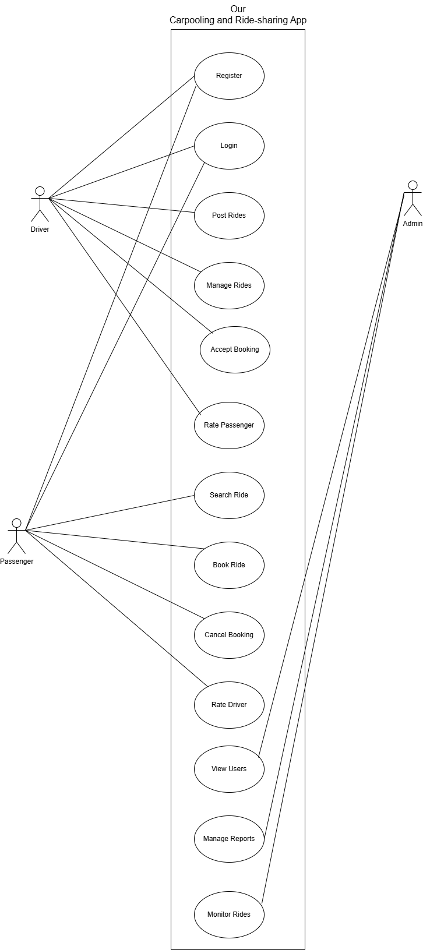
2.3 Class Diagram (Core Classes)
This section shows the main classes used in our system. Each class has data (attributes) and actions (methods). We use inheritance to reduce repetition. The User class is the parent class for both Driver and Passenger.
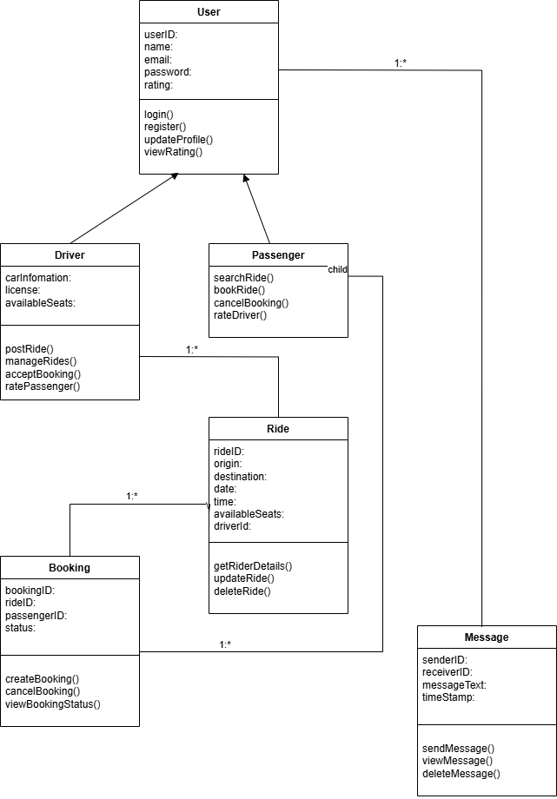

2.4 User Interface Design
This section describes what each screen in the app will look like and what the user can do there. The app will have a clean and easy-to-use interface, designed for both Android and iOS users. There is also a web-based interface for Admin users.
Login Page and Sign Up Pages
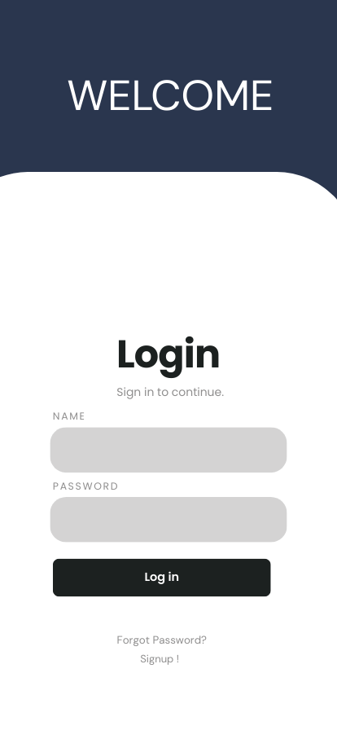
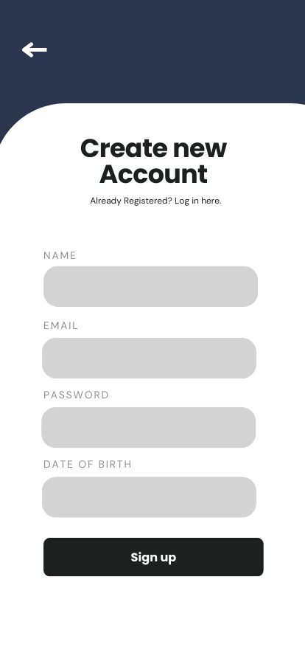
Home Screen
Drivers View
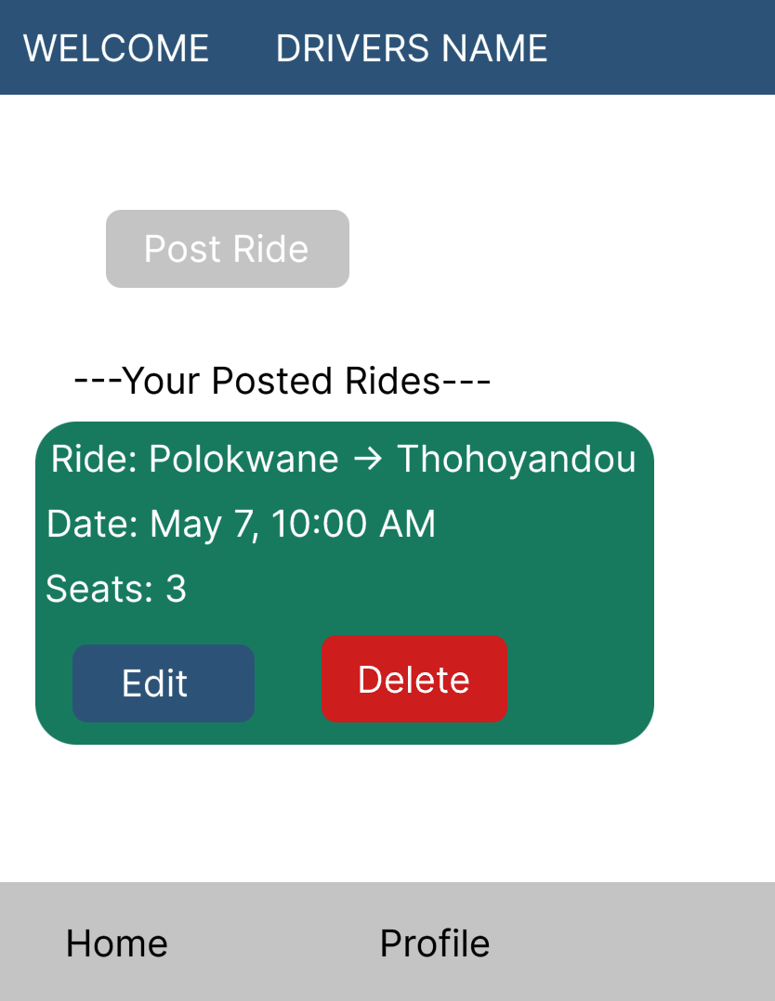
PASSENGER VIEW
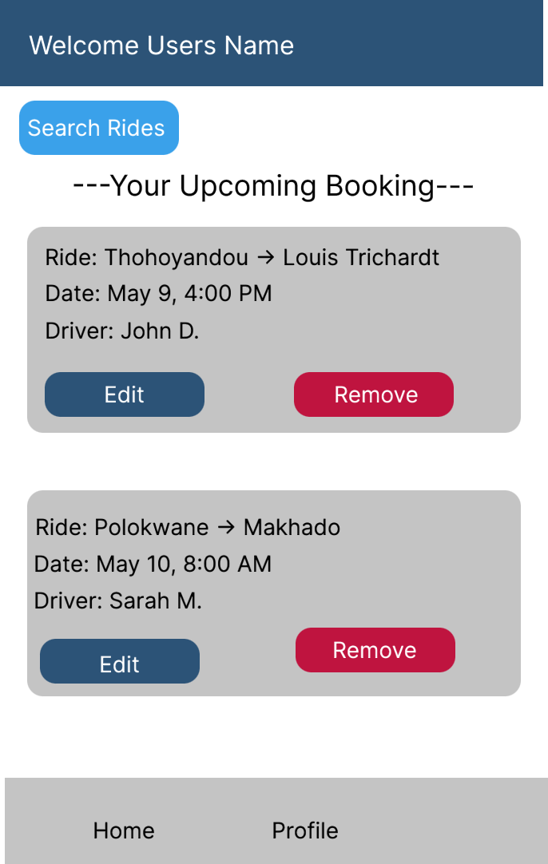
Ride List
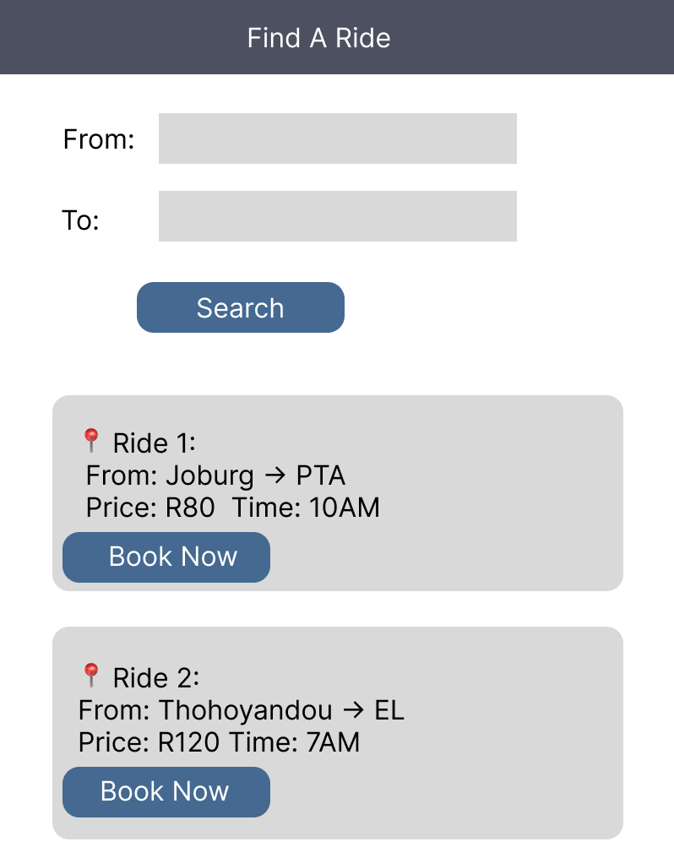

Confirm Booking
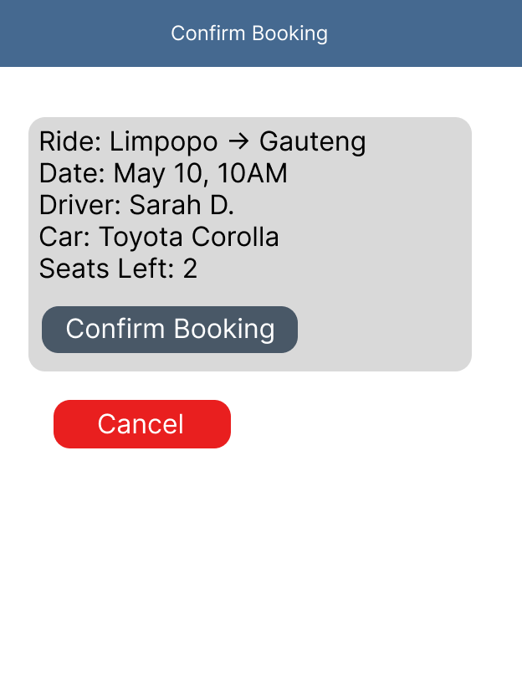

PROFILE
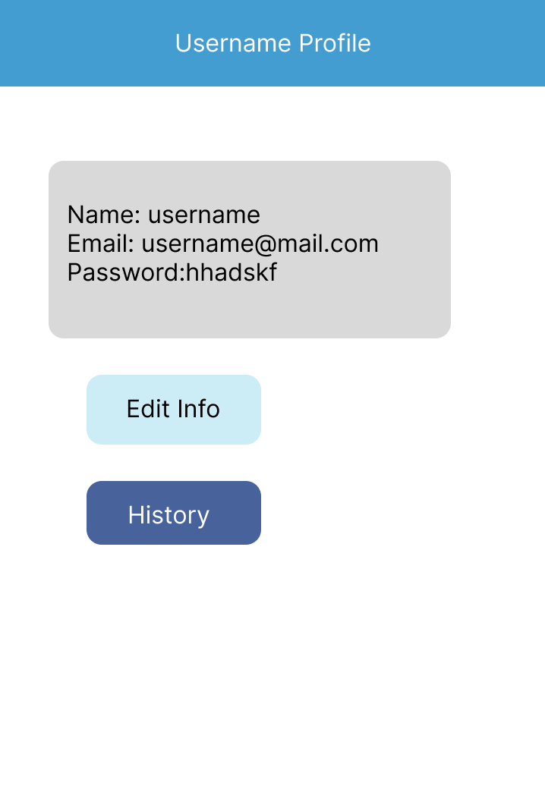
ADMIN DASHBORD
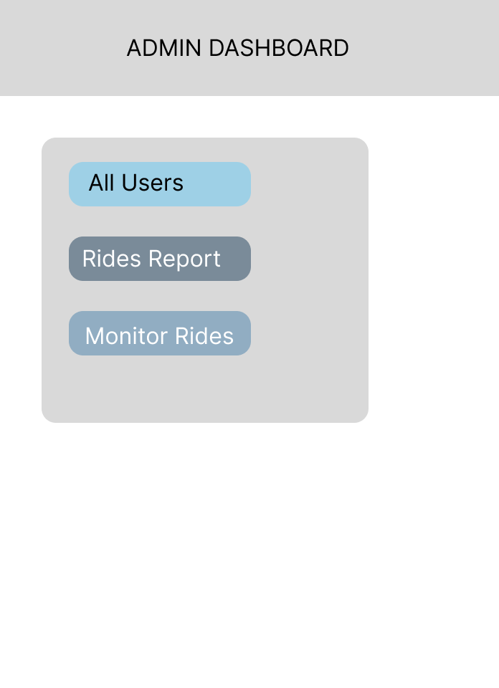

Sequence Diagram

